Student monitoring system with Face Authentication based on NFC

Anagha T¹,Ananya M²,Keerthana M A³,Lavanya V⁴,Kiran P⁵
Dept.of Computer Science and Engineering RNS Institute of Technology,Channasandra Bangalore,India¹²³⁴,
Professor and HoD,CSE,Dept.of Computer Science and Engineering RNS Institute of Technology,Channasandra Bangalore,India⁵,
anagha.thyagaraj@gmail.com,ananya@gmail.com,keerthana@gmail.com,lavanya@gmail.com

Abstract—Even in the present time there are many of those in- stitution where the students record are been registered manually either to track hold of their information, to track their attendance or to check their actual presence . But these records are kept in the form of register basically a mere paper representation and then they are collected or registered to the data store if present. In these situations, there are likely to have some mismatch of the entry ,time consuming and tiresome to do, data loss even worst a proxy registration. With vast improvements in the face recognition technologies and algorithmic technique we can overcome this problem by combining these field with NFC cards. The NFC cards with unique id provided with each card, we are linking the students records such that the work in the manual process is reduced and each time a card is placed on the device it asks for user authentication reducing the proxy registration or mismatch entries. By collecting the students facial features as for the authentication purpose Haar-cascade , LBPH methodology is used to get better facial feature for recognition combined with Adaboost enhancing it’s efficiency and at last having a reliable storage using MySQL connector. With the Tkinter pacakage we can easily register the student’s required details by creating a GUI such that even a layman can register the details without any efforts.
Index Terms—NFC, LBPH, Haar-Cascade, Adaboost.

- INTRODUCTION
The issue in the present-day situation among the institu- tions is tracking of student’s attendance which is also an important measure in analysing their performance and other factors. There have been many such case studies reflecting on managing and analyzing the student record and track of their attendance. Since the institutions use a manual way to
take attendance of the students i.e., by either each lecturer maintaining a register for each class or a course and manually recording it by calling out their names in their respective classroom. Another way is computerized, where each student enters their entries in the computer database maintained for respective batches. As these ways are time-consuming in manual process and while using the computerized method there would be proxy attendance and may also mismatch or in the event of power loss then we would end up losing the data entries if not been saved. Hence, we try to resolve these issues with current developing technologies such as IoT and AI-ML fields. The face recognition and face detection techniques of image processing combined with the IoT device such as RFID readers to specifically identify and mark each student.
- LITERATUTE SURVEY
There have been most of the case studies and methodology have implemented monitoring and tracking of student atten- dance systems. Among them, Dela Cruz and paglinawam[1] provided a system utilizing Viola-Jones Face detection Tech- nique and Principal Component Analysis(PCA) method for faulty face recognition system integrated with biometric fin- gerprint verification using Arduino. This system provided greater accuracy and effective test results to automate the faulty attendance system.[2] Benyo et.al has developed and implemented a biometric authentication system with nearfield communication identification tags using system terminals. But this method gave an effective test result for small size of input
i.e fewer strength students and thus was only applicable to

smaller universities or colleges. With advanced improvements in the field of IoT, many researchers expanded their methods integrated with IoT in search of acquiring better test results and accuracy. Jacob et.al [3] proposed a solution to integrate student NFC cards with a one-time password. The lecturer starts the Ardunio and the students place their cards such that SMS is sent to their registered number integrated with the card as enrolment details. Using the OTP sent they log in to the web application created by the lecturer and mark their attendance. Masruroh et al.[4] used a mobile-based application to track the student’s presence, when a student login to their course they need to provide the NFC cards which then authenticate the user to capture the images and update the student’s attendance and it’s activity and can get a generated report to analyze student performance. Face recognition technology has improved enormously over the past few years with the AI- ML field expanding provide a pathway for other sub-field to grow, as such image-processing with computer vision as many vast applications developed and solving complex problems. Anirudh Adukkathyar, Gokul Sri Krishna [5] provided a user would have to enable secure business transaction dealings with his/her numerous accounts using an NFC card with a Face recognition system. Whereas Priyanka Wagh, Jagruthi Chaud- hari [6] used various techniques like the viola-Jones algorithm, illumination invariant, and PCA analysis to achieve better results by overcoming the issues faced previously. Srinidhi MB, Romil Roy [7] Utilizing biometrics and RFID basis m-tier architecture developed a safe and secure web-based monitoring system, which can maintain the attendance record of both staff and students using smartphones and computers.
- EXISTING SYSTEM
Each of the previously mentioned methods propose to make a framework with a server where all the mobile phones are associated to it to enable all the information is preserved in one dataset on mobile phones and to be sent to the server as well.This makes the data observing more straightforward. All of them should have a mobile phone containing NFC for each of the users where they can use the NFC cards and camera to take photos of their face. The camera is there for understudy of NFC tag to the cohort class, contact the other understudies’ NFC tag to cause it to show up as though he/she had likewise gone to the class. At the point when an understudy enters the class and contacts his/her NFC label on the teacher’s cell phone, the NFC per user peruses every understudy’s tag of NFCs , on the other hand the camera on the mobile phone is there to concurrently take the photograph of the user and transmits it to the dataset on the educator’s cell phone. After some time, the educator presents all information for reinforcement in an application data set server.
A. Distinguished Problem
Participation framework is a framework that is utilized to follow and prosperously deal with the participation of a specific individual and is useful in the colleges, schools,work place etc.The physical attendance recording framework isn’t
proficient as well as it is tedious to orchestrate records and to compute the typical participation of every understudy. Subsequently a framework has been carried out that enables programmed participation to be highly exact and diminish physical work of humans.

- PROPOSED METHODOLOGY
In this work, we are aiming to build an IoT based atten- dance monitoring system based on previous contributions and implementation, our study has shown that using RFID, ex- plicitly nearfield communication(NFC) readers and tags used for individual students to monitor them, collaborating with the IoT device with advance Ai-Ml technology such as computer vision for image processing to provide authentication for every user by extracting their facial features using a face recognition system and also to detect their face with the face detection system. This reduces the manual effort in registering each student, also reducing the time consumption and reducing the proxy. We have considered the Local Binary Pattern Histogram algorithm with haar-cascade to extract better facial features of students, whereas in LBPH algorithm increases the efficiency of the model using various image processing techniques and a distance metric to provide correct results. Haar-cascade with Adaboost helps to narrow down the facial features extracted and discard the redundant unnecessary features. Using the Tkinter package we have provided a basic web interface frame- work i.e the GUI to help the user to interact with the system and train the models with ease. The hardware NFC reader and tag device are synchronized with the software application i.e the face recognition and detection system to provide a full- fledge interface to track and monitor student attendance. As each NFC card with a unique id will be assigned to individual student details which are their facial characteristics to extract features for authentication, these data are stored and managed in a database using the MySQL server such that we can access the login details of the students. Authorized Student provide their NFC cards and face recognition detects and recognize the face and if it is a match then we have used a cloud Saas service to provide SMS services specifying a used login else the code ends up giving a proxy message as an output to overview.

- SYSTEM ARCHITECTURE
In this work, a model is proposed to track and register individual students’ details. The proposed system architecture is shown in the figure which provides the basic workflow of the model. As shown the below figure it helps an individual to place their cards on an Arduino device integrated with an NFC reader and tagset from where the micro-controller inputs a unique ID from the cards.This device is then synchronized with a laptop or a computer device prompts for Face Recogni- tion System by triggering the camera application, which is then followed by a GUI-based application for further processing and storing the collected data in the database.The databse used is a relational database for storing the details of the registered individual.

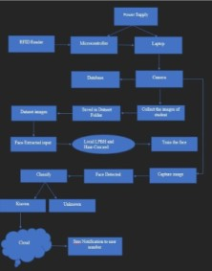

Fig. 1. Architecture Diagram.

GUI application classifies an individual as a known or un- known entity and provides an authenticated message to the authorized person’s register number using ThingSpeak IoT analytics from the cloud.
- Hardware System Architecture
  - Near field Communication (NFC) Cards:
Near field Communication is a low-range remote innova- tion and it permits correspondence between gadgets when they are connected to each other, or coupled within the range of a fewer distance.NFC ha been specific part of RFID innovation. It requires less power consumption and it also doesn’t need a proof that the gadgets are together.
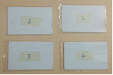
Fig. 2. NFC Cards.

- Hardware System Components
  - LCD: It is a simple to-utilize display module, It can make display more straightforward. Utilizing it can decrease the trouble of make, with the goal that producers can concentrate on the elemental part of the work. Here in this scenario LCD is useful for displaying the details w.r.t student unique ID which includes scanning of the NFC tag of each student where the ID read will be displayed.
  - I2C: I2C stands for Inter-Integrated Circuit. It is a communication protocol which are combined together to enable a serial communication.In recent years, it has been a terminology for communication within a lesser distance. It is also called as Two Wired Interface.

Fig. 3. NFC reader with its components.

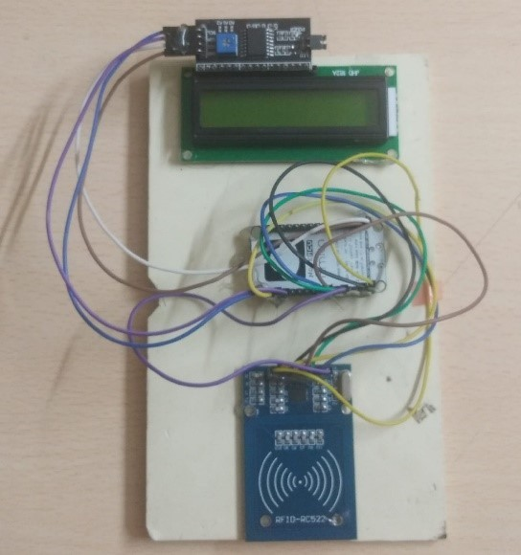
- NodeMCU: NodeMCU is an open-source firmware for which its components are easily available. The name ”NodeMCU” joins ”node” and ”MCU” (micro-controller unit).The firmware for and prototyping board plans for NodeMCU is openly available(open source).
- RC522 MFRC-522 RFID Module: This RC522 RFID Development unit depends on NXP’s a profoundly in- tegrated reader/writer IC MFRC522 for non link inter- actions at frequency of 13.56 MHz.It enables ISO/IEC 14443 A/MIFARE and NTAG. The MFRC522’s has an internal vector that can push a reader/writer radio wire to communicate with ISO/IEC 14443A cards and telemetries without extra dynamic hardware.

- Software System Architecture
  - ThingSpeak Cloud:
ThingSpeak is an IoT analytics platform that facilitates services that allows us to analyze,visulaize the live stream of cloud data. Thingspeak is analyzed using matlab plat- form which analyzse the aggregated data and visualize it. We can use thingspeak with many iot devices such as Rasberry pi,LoRawan,libeliu, ardunio and many more. We are using Arduino device with Resyt api to use a sms service, which is used to send an alert message for an individual login.

- IMPLEMENTATION
- Targets
  - To limit administrative work and save time with versatile and online interfaces.
  - To upgrade perceivability to follow and keep track of understudy attendance of the students.
  - To give simple participation recording utilizing NFC with face authentication system for participation framework.

- Major Technologies used
  - NFC: It send the data which is under study and trasmits to the radio waves. The innovation encapsulated is propor- tional the Radio Frequency Identification (RFID) thought and this is utilized for the EM acceptance for data communication.
  - Face recognition: Facial Recognition involves registration of user’s face or usage of set of dataset images of different users to be compared with the face of a person and produce the detection results.Here the person can capture the image of oneself using PC/laptop and that image is compared to set of images on a dataset and the recogtition results will be generated as to whether that person’s face is detected or not.
- Algorithms utilized
  - HAAR Cascade:
HAAR Cascade utilizes Haar like features for recognition of human face. The three types of features that are commonly available are edge feature, line feature(nose) and four rectangle features(mouth).The Algorithm has a requirement of a AIML Haar features of the face to be recognized. It takes the images and transforms it into 24*24 window and puts Haar-Feature across each of the pixels. For the initial training of the classifiers the algorithm makes use of positive and negative images. i.e facial and non-facial images.
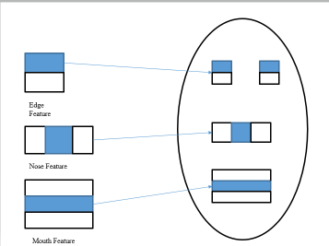
Fig. 4. Types of features.

Then there will be the extraction of these features. Features are calculated by using the formula:

Feature = (pixels in dark area) - (pixels in light area)

A 24×24 pixel window gives a result for about 16000 features. Integral images are designated as 2D lookup tables.2D look up tables look like a matrix whose dimensions are same as original image.Each section of lookup tables is designated as summation of all pixels equivalent to the top left corner of the original image.
Sum=I(G) + I (E) –I (F) – I (H)

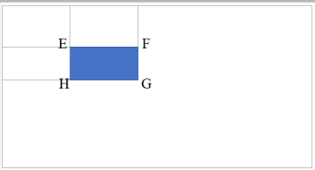

Fig. 5. Finding the sum of shaded area.

Here E,F,G,H are the points of integral image.

- Local Binary Pattern Histogram(LBPH):
LBPH a.k.a Local Binary Pattern Histogram is one of the most well known Face Recognition Algorithm which makes use of local binary operators where the grey scale of an image is locally numbered as 0s and 1s based on a threshold value and concatenation of which gives a decimal value whose characteristic value is similar to the original image.It is helpful in recognizing the faces from sides and front.
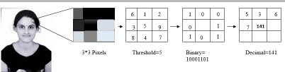

Fig. 6. LBPH pixel value flow.

The figure 6 represents a person’s image in gray scale which consists of 3*3 pixel in the form of matrix and the values of those pixels ranges between 0-255 pixel intensities.The central value of the matrix is taken as threshold value.Then the pixels are numbered in binary values based on threshold value where the threshold value is not included.The value is 1 when the neighbour is grater than the threshold value and 0 otherwise.Then all of these values are concatenated together in clockwise direction to form a binary number.Then this number is converted to decimal value and then the obtained decimal value is placed at the center of the matrix.This value represents upgraded characteristic of the image which was in its original form.Then that image is divided into X and Y axis grids where each grid has a histogram which represents pixel intensity values from 0-255 and all of these histograms from all such grids of gray scale get combined together to form a single histogram which represents upgraded characteristic of initial image.

- Adaboost:
Adaboost algorithm i.e Adaptive boosting algorithm involves combining a set of weak classifiers in order

to form a single strong classifier.Weak classifiers do not classify the images well.Therefore they are used in collaboration with Haar like features where positive and negative images are classified based on the threshold values by Haar feature.

Adaboost algorithm:

- For the given set of training examples(x1,y1)—- (xm,ym) with two possible values -1 for negative images and +1 for positive images first we will initialize the weights of each training examples with 1/m where m-number of images.
- Then for T number of iterations starting from 1 do the following:
Train the weak learner using the previously ini- tialized distributed weights .
∗
Get the weak classifier ht i.e predicted values of positive and negative images which have two possible values +1 and -1.
∗
Then select the weak classifier with lowest mis- classification rate.
∗
Calculate the weight of the classifiers.If the classi- fier has misclassification rate less than 0.5 weights are positive and if the misclassification rate is greater than 0.5 then the weights are negative and 0 for 0.5 error rate.
∗
For the misclassified ones update the weights to increase its weights to more positive side and continue through the m iterations until all the misclassified classifiers are properly classified.
∗
- Then combine all the weak classifiers which is the summation of product of their weights with classi- fiers themselves to obtain a strong classifier H(x).
- RESULT ANALYSIS
In our developed project we start the initial phase with registering the students in the database with their facial features, the figure 7 shows the GUI format of registering the student details i.e., their id and name. Then the camera is triggered to take images of individual student for enrolling it in the database. These images are used to train the model as shown in the figure 8.
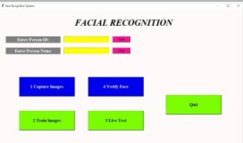
Fig. 7. Collecting the image samples for training.

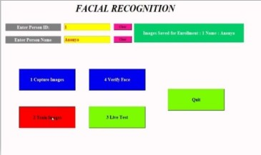

Fig. 8. Training the pictures.

For testing and authentication of the user we can verify the individual face as shown in the figure 9.We can also test our face recognition and detection model’s accuracy by only doing live test as shown in the figure 10 which gives the precision of the face detection system, confirming the effective working of the initial phase.
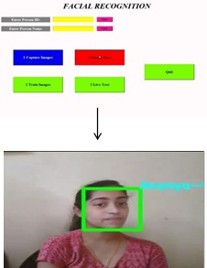
Fig. 9. Verifying the face with the prepared arrangement of information.

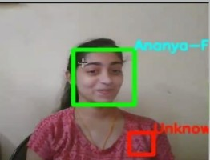

Fig. 10. Predicting the client’s name through live test.

After enrolling each individual student entry in the database as shown in the figure 11 and training the model by taking their sample images. We then synchronize the NFC cards with the individual enrolment such that each individual has

their own NFC cards registered with their ids. Thus, after synchronization and register if a student place his id card on the device as displayed on GUI show in figure 12. NFC reader reads the unique id followed with the application for facial detection. If the registered id matches the facial image of an student we provide an message displaying known user identification and an alert message to the registered user phone number as shown in figure 13 or else it displays unknown as and a display of an proxy at the output terminal of the application as shown in the figure 14. We also have an registered login details of the student’s shown in the figure 15 which can used for various analysing task.
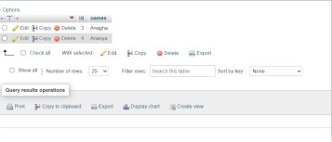
Fig. 11. Database entry.

Fig. 12. Registering the NFC Card.

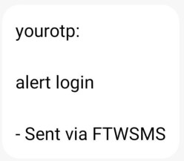

Fig. 13. An Alert message sent to the authorized person.

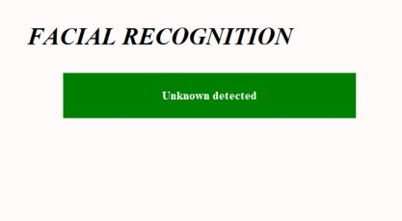

Fig. 14. Unknown face detected.
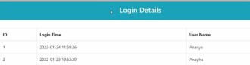

Fig. 15. Login details of recognized faces.

- CONCLUSION
In this paper, student attendance management system that makes use of NFC cards integrated w with IoT technologies and face recognition were proposed.We proposed a solution using LBPH with Haar-cascade. algorithm to get better effi- cient test results. Radio frequency is used by the NFC cards to utilize the information and to send it to the cloud service for an authentication message for an authorized registered person number. LPBH algorithm used will provide better confidence in detecting the face of an individual and haar- cascade enhanced with Adaboost helps to extract the relevant features by dropping the redundant unnecessary ones thus reducing the overall computation. With the database connected through MySQL, the connector provides better storage and accessibility, such that student log-in details can be utilized for further analysis if needed.

- FUTURE WORK
In our proposed model we have used a database to store the student log-in details, but it will be tedious to maintain huge data in the database and will be time-consuming while access- ing an individual record and query the data for analysis and visualization of the individual record. Thus, we can utilize the cloud service for database storage and built-in analytics tools available which will increase the performance and reduces the computation work of the system. And also, for identical twins face recognition authorization isn’t an effective authentication method, so we can include a fingerprint module. By inclusion of the fingerprint module authentication for identical twins will be an add-on and also other individual authentication will be effective in result accuracy.

REFERENCES
- D. Cruz, et al.,” Biometrics Based Attendance Checking using Principal Component Analysis”, School of EECE Mapa Institute of Technology Intramuros, Manila, Philippines, 2015.
- B. Benyo´, B. So´dor, T. Doktor, and G. Fo¨rdEs, ”Student attendance monitoring at the university using NFC,” in Wireless Telecommu- nications Symposium 2012, 18-20 April 2012, 2012, pp. 1-5, doi: 10.1109/WTS.2012.626613.
- J. Jacob, K. Jha, P. Kotak, and S. Puthran, ”Mobile attendance us- ing Near Field Communication and One-Time Password,” in 2015 International Conference on Green Computing and Internet of Things (ICGCIoT), 8-10 Oct. 2015, 2015, pp. 1298- 1303, doi: 10.1109/ICG- CIoT.2015.7380666.
- S. U. Masruroh, A. Fiade, and I. R. Julia, ”NFC Based Mobile Attendence System with Facial Authorization on Raspberry Pi and Cloud Server,” in 2018 6th International Conference on Cyber and IT Service Management (CITSM), 7-9 Aug. 2018, 2018, pp. 1-6, doi: 10.1109/CITSM.2018.8674293
- A. Adukkathayar, et al.,” Secure multi factor authentication payment system using NFC”, International Conference on Computer Science Education (ICCSE), Cambridge University, UK, 2015.
- P. Wagh, et al.,” Attendance System based on Face Recognition using Eigen face and PCA Algorithms”, Sandip Foundation’s Sandip Institute of Technology and Research Centre., Nashik, India, 2015.
- R. Roy, et al.,” A Web Enabled Secured System for Attendance Mon- itoring and Real Time Location Tracking Using Biometric and RFID Technology”, IIT, Kharagpur, India, 2015.
- R Nandhini, N Duraimurugan, S.P. Chokkalingam “Face recognition- based attendance system” Int. J. Eng. Adv. Technol. (IJEAT), 8 (3S) (February 2019).
- Senthamizh Selvi.R , D.Sivakumar, Sandhya.J.S , Siva Sowmiya.S, Ramya.S , Kanaga Suba Raja.S, Face Recognition Using Haar - Cascade Classifier for Criminal Identification, IJRTE ISSN:2277-3878,Volume- 7,Issue-6S5,April 2019.
- Savitri Paharekari, Chaitali Jadhav, Surabhi Nilangekar, Jitesh Padwal, “Automated Attendance System in College Using Face Recognition and NFC”, IJCSMC, Vol. 6, Issue. 6, June 2017.

